JJ Burien
14825 N Deer View Trl
Prescott, AZ 86305

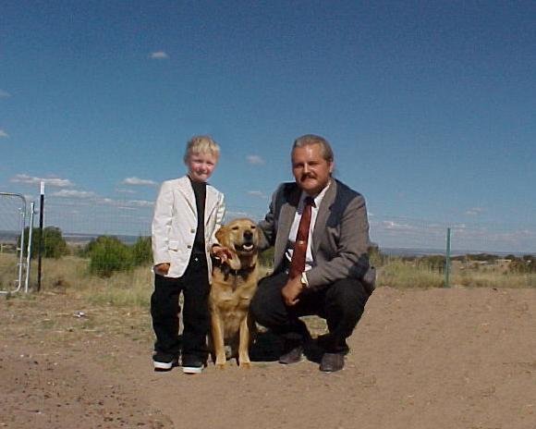

JJ, Beasty Beast and DAD

JJ:

Enclosed are your school pictures and the pictures from your trip to DC to see George Bush and then your trip to the Statue of Liberty.

The kids at the school in Prescott will love to see your pictures and your school pictures you can give one to mom, grandma and grand pa, and one to Pete. Also you can give one to your new girl friend at school.

Hope to see you soon!

Love Ya!

Dad and Beasty Beast.

Say Hi to Gloria for me :<)

The CD that I sent has hundreds of pictures on it from 1998 to 2006. My whole collection of pictures! Your mom can help you look through them with Gloria. Miss Ya!

