Walter J. Burien, Jr.
P. O. Box 2112
Saint Johns, AZ 85936
Telephone: (928) 458-5854

IN THE SUPERIOR COURT OF THE STATE OF ARIZONA

IN AND FOR THE COUNTY OF MARICOPA

Walter J. Burien, Jr., No. DR 2000-090543
Petitioner,
V. EXPEDITE REQUEST FOR ORDER
Debbie C. Burien (Watton) SUMMER VISITATION OR IN THE
Respondent. ALTERNATIVE A HEARING SET
(EXPEDITE REQUESTED WITH CAUSE)

HONORABLE JUDGE: DAVID B. GASS

Petitioner, hereinafter the Father, submits the following; EXPEDITE REQUEST FOR ORDER OF THE COURT SUMMER VISITATION with his son John Joseph Burien age 12, or in the alternative a hearing set, expedite requested with the following good cause;

- Petitioner’s son is now 12-years old and due to the complete and total lack of cooperation from the mother, the father has not had any parenting time with his son for the last six-years. The Father had custody of his son for the first six-years of his son’s life and during that time the father provided open access to the mother to exercise parenting time, visitation, and contact with the child. Since the mother has had custody since December of 2005, the exact opposite has occurred and to the detriment of the child and the father.

- For the last six-years the mother and her immediate family has made every attempt to poison the child towards the father and has consistently crossed the line with conduct that by definition is emotional and developmental child abuse. In the last six-years the mother did not talk with the father but on two occasions. Father’s attempts to exercise once a day court ordered phone calls to the children resulted with 1 in 20 calls on average reaching the child, and even then the call would be monitored and the child being instructed to hang up the phone if the call was commencing in a positive tone. No information was provided the father per the child’s schooling; medical treatments; and the father learned that mother was incarcerated for a period of time on an extreme DUI arrest and the father was not informed that the mother was in jail not available to exercise custody over the children. The father became aware of this circumstance upon a search of the Prescott Criminal Court records. Mother’s conviction record attached and marked Petitioner’s EXHIBIT (CR)

- When custody transferred from the father to the mother by court order dated 02/26/06, the court addressed parenting time for the father stating page 4, first line: “Father is to file a notice with the Court immediately upon his return to Arizona and a hearing will be set on the issue of temporary orders to allow him to exercise parenting time with the children” petitioner’s EXHIBIT (A) is page 4 of the 02/26/06 minute entry. When father was able to return to Arizona, he filed on 10/04/06 a request for a hearing, waited six months for a hearing to be set, calling the court several times requesting that his motion be granted and the court then issued a minute entry on 04/04/07 “abandoned” petitioner’s EXHIBIT (B) is a true copy thereof. Again father towards the end of 2008 filed an expedited request for a hearing before the court and on 04/13/2009 the court by minute entry denied father’s request for a hearing before the court. Petitioner’s EXHIBIT (C) is the minute entry of 04/13/09.

- Father has paid mother in child support over the last 23 months $12,759 from 06/08/10 until 05/10/12. The mother has primarily used the funds to buy a new car.

- Father recently acquired a motorcycle that gave him the ability to make the ten-hour roundtrip drive from his property in Saint Johns to Prescott economically. The father has not seen his son in six-years due to the non-cooperation of the mother. At the beginning of April the father discussed with his son stopping by where he currently resides for 5 to 10 minutes to see his son. His son John was happy at the opportunity to see his father and asked him to stop by on Saturday, April 14th 2012.
I told my son I would bring him a CD with pictures on it and take a picture of him sitting on my motorcycle, make copies for him that he could give to his friends, and I asked my son to ask his mother; grandmother; and the mother’s live-in boyfriend of the last 10-years if they would like me to take them all out for lunch after I briefly stopped by. They declined via comment to my son. I asked my son to have one of them come to the phone so I could speak with them and they refused to do so.
The weather forecast for 04/14/12 was a high of 43 degrees, being too cold to take the trip by motorcycle so I canceled and asked my son if the following Saturday, April 21st 2012 where the weather forecast called for warm weather was OK and he said OK. I again asked him to have one of the adults that lived there to come to the phone and if they would like to have lunch at my expense on the 21st and again they refused lunch or to come to the phone.
Prior to 04/21/12 and on 04/21/12, I requested a Yavapai Sheriff to come with me for a civil standby as a witness being that I was very familiar with the propensity for the adults living with my son to be hostile; demeaning; and lie in their attempts to cause damage. The several Yavapai Sheriffs I spoke to said they could not come as a civil standby.
On 04/21/12 at 10:04 AM, I stopped by where my son lived; he was waiting for me and came quickly to me. I said “Hi big guy” and gave him a hug for the first time in six-years, took my camera and the CD out of my saddlebag, and grandma, Darlene Fuller approached me walking down from the house taking advantage of my visit to be demeaning and hostile in front of my son from the first word out of her mouth and continued to be as such in her comments.
Then Hank, the live-in boyfriend approached a minute later from the house also being demeaning and hostile. I remained civil and polite and made one comment to Hank, a question: “Hank did you ever have a motorcycle?” He replied “no” and his demeanor instantly changed to normal.
I then gave my son the CD and took a picture of him standing by my motorcycle. Petitioner’s EXHIBIT (E). Grandma remained being hostile in front of my son and told me to leave. I put my camera back in my saddlebag, strapped the saddlebags back up, got on my motorcycle, waved goodbye to my son and the mother who was standing on the porch of the house with our daughter Gloria about 150-yards away, and I left at about 10:10 AM having stopped there on my visit for about six-minutes or seven-minutes. I drove about a mile to the exit of their development and stopped at a Firehouse, parked the motorcycle and called the Sheriff to update him on the results of my stop to see my son.
I mentioned I stopped by for a few minutes, the adults were hostile and demeaning, so I left. He told me to wait there for him at the firehouse, and I did.
He arrived about 5-minutes later with another Sheriff Sargent, his supervisor. The supervisor then went over to the residence where my son currently lives and spoke with Darlene Fuller, the mother, and the live-in boyfriend Hank for about a half-hour.
In line with Darlene Fuller, the mother, and the live-in boyfriend Hank’s propensity for fabrication and lies, they told the deputy I was there for 25 minutes and refused to leave and each signed statements demanding I be arrested for trespass.
Based on their signed statements I was arrested for trespass and my motorcycle was impounded. I was released the following day, Sunday and I then secured my motorcycle and returned to Saint Johns.
I brought to the attention of the Sheriff and the prosecutor in that matter that I was sitting at the Sheriff depot station until 9:56 AM on the 21st and spoke with a Sheriff deputy from there at that time just before I headed off to say hello to my son (a 7-minute drive to his current residence) and called them after the visit at 10:16 AM from the firehouse (a 4-minute drive from the residence) to update them on the visit.
So the Yavapai Sheriff’s own phone logs with me establish that my visit lasted from approximately 10:04 AM to 10:11 AM, a 7-minute visit establishing the three statements signed saying I was there for 25-minutes to be false with the intent to cause harm and damage to this father by false statement.
Based on evidentiary findings it is most likely that the three false statements signed will lead to the filing of charges by the Yavapai prosecutor against Darlene Fuller, the mother, and the mother’s live-in boyfriend Hank for signing false statements given to law enforcement, a potential 3-month jail sentence for each and the charge of trespass will be dismissed against myself.

- This father wishes to remove his son from the continued hostile and demeaning environment he is being exposed to where he currently resides. In the care of the mother John’s development has been marginal both emotionally and physically at best.
Summer visitation spent with his father will be very productive and beneficial for him both emotionally and physically. The father has trust property in rural Saint Johns, AZ, that he established for his son John in 2000 that will go to his son when he turns 24-years old.
The father currently resides at that location with his 9-pups. If a Google Maps search is done for the pen-name the father writes under, CAFR1 it will zoom in right on the location. There is a sunset picture that displays after that Google Maps search is done, if clicked on it will display several pictures of the property. When the link on the lower left of the page to view “More Photos” is clicked on a good representation of the property can be viewed.
There are two structures; a mobile home and a motor home. John over summer will have his own room, frig, bath, bed, TV, Internet, and phone access.
Most importantly he will be able to take many hikes with his father and the pups, do some camping, take trips to Show Low, become familiar with the property he will inherit, learn good responsibilities, cook, travel, and learn mechanics, computer operation, swimming, and I have the intent of getting him a mini-bike to ride in this rural setting.
The mother can have alternating weekend visitation during the summer if she chooses. And, as has not been the case over the last six-years, in the alternative the father will encourage active phone calls and positive interaction between our son and his mother.
Most importantly, the consistent and egregious poisoning of John that has taken place over the last six-years at his current residency will be abated. I will note that this father had very good parents. Both of his parents were psychology majors and were directors in state and county government in NJ.
This father’s mother for 32 years until retirement was the head supervisor for the Middlesex County Welfare Board child and legal support unit, the equivalent of DES / CPS in AZ with her overseeing 4.5 million residents.
Petitioner’s Father was for a time the Personnel Director of the NJ State Treasury overseeing all state employees and retired as the head Corporate Compensation Manager for Johnson and Johnson. He determined all executives’ salaries and benefits both domestically and internationally.
I grew up from early youth until a teenager hearing regularly from both parents that in a divorce case, separated parents should be as positive as possible per the other parent. That it was the worst thing possible to expose the children to demeaning and hostile actions toward the other parent. In doing so it was extremely detrimental to the child’s development and emotional standing.
I have always taken my parents teachings to hart following their example taught at every opportunity with my own children. Reciprocation from the mother of the same to date has been non-existent and in fact strongly to the contrary.

Petitioner THEREFORE, requests that the attached ORDER for summer visitation with his son John Joseph Burien be granted, or in the alternative an expedited hearing be set and held before the court in this matter. Summer vacation for John starts at the end of May and the father requests that summer visitation with his son in Saint Johns, AZ start as of Saturday, June 2nd 2012 and end Sunday, August 26th 2012. The father is not requesting summer visitation with his daughter Gloria age 11, being that she, this father is sad to say, has been irreparably poisoned by the conduct of the mother; grandmother, and live-in boyfriend to where it would be detrimental if extended visitation occurred at this time.

Respectfully submitted,
Dated this 12th day of May 2012.

_____________________________________ Walter J. Burien, Jr. – Pro Per
CERTIFICATION
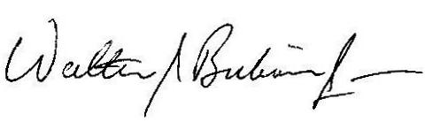
The forgoing; statement; facts; presentations requests for Order of the Court for discovery are true, accurate, and necessary in this matter to the best of my knowledge.

Walter J. Burien, Jr.

Copy of the foregoing EXPEDITE REQUEST FOR ORDER SUMMER VISITATION mailed this 12th day of May 2012, USPS PRIORITY Mail to:

Maricopa Superior Court
Filing Counter - CLERK OF THE COURT
222 E Javelina Ave.
Mesa, Arizona 85210

AND this 12th day of May 2012 by USPS 1st Class Mail to:

Troy Brown
1757 E. Baseline Road, Suite 130
Gilbert, AZ 85233

Attorney for Respondent

And copy mailed US 1st Class mail on the 12th day of May 2012 to,

Honorable David B. Gass
222 E Javelina Ave. Suite 301
Mesa, Arizona 85210

Petitioner’s EXHIBIT (A)
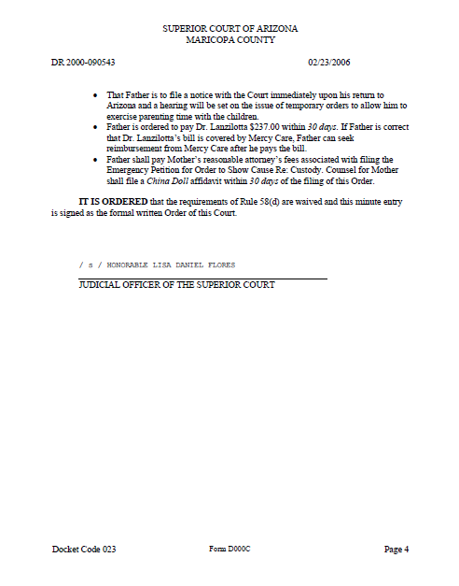

Petitioner’s EXHIBIT (B)
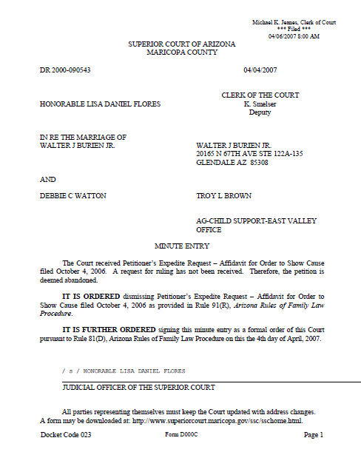

Petitioner’s EXHIBIT (C)

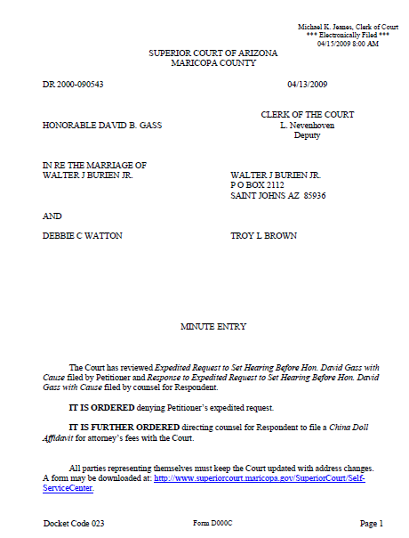

Petitioner’s EXHIBIT (CR) – 4 pages

Criminal Docket: 2007060010J, DEBRA CARESS WATTON - Prescott AZ Justice Ct
Criminal Docket: 2007060010J, DEBRA CARESS WATTON - Add/Change Docket - 2:10 PM Apr. 26, 2009

Defendant Name | WATTON, DEBRA CARESS
Street Addr | 14825 N DEERVIEW TRAIL
City | PRESCOTT AZ 86303
Def DOB | 5/17/1975
Suspense | 5/20/09:Y> paY
Bond/Deposit | $2,710, $6,550, Tot= $9,260
Case Location | D> Docket
Agency Dr# | 07-19359
Court | J> Justice
Balance | $1455
Comments 1 | 6-2-07; Ppr Bd Posted $2,710 By Speedy Release
Comments 2 | 7-24-07 Dispo Sent Bond Exon
Suspense History | 5/20/09:Y 4/20/09:Y 11/20/09:Y 10/20/08:Y 9/20/08:Y 8/20/08:Y 7/20/08:Y 6/20/08:Y 6/16/08:Y 5/20/08:Y 4/20/08:Y 3/20/08:Y 2/20/08:Y 1/20/08:Y 9/20/07:Y 8/20/07:Y 7/18/07:P 6/27/07:P 6/1/07:I
Criminal Docket: 2007060010J, DEBRA CARESS WATTON - Case Charges

Statute | Citation | Cit Date | Officer/Clerk | Fine | Disposition | Dispo Date | Date Filed
28-1382A | 117946 | 5/31/2007 | Y5031 | 450N+10PS+1000PO+1000DP+250DA | 11-3 | 7/18/2007 | 6/1/2007

Type: EDUI | Tss: N Pt: 8 | Title: DUI; With Alcohol Concentration Of .15/More (Cl 1 Misd) | Fine: 450N+10PS+1000PO+1000DP+250DA

28-1381A2 | 117946 | 5/31/2007 | Y5031 |  | 44-3 | 7/18/2007 | 6/1/2007

Type: DUI | Tss: N Pt: 8 | Title: DUI With Alcohol Concentration Of .08/More (Cl 1 Misd) | Fine: 450N+10PS+500PO+500DP

28-1381A1 | 117946 | 5/31/2007 | Y5031 |  | 44-3 | 7/18/2007 | 6/1/2007

Type: DUI | Tss: N Pt: 8 | Title: DUI; Alcohol, Drugs, Toxic Vapor Or Combination (Cl 1 Misd) | Fine: 450N+10PS+500PO+500DP

4-251A1 | 117946 | 5/31/2007 | Y5031 |  | 44-3 | 7/18/2007 | 6/1/2007

Type: MIS | Tss: N Pt: 0 | Title: Consumption Of Liquor While Operating Or Riding In Vehicle | Fine: 450N+10PS

28-701A (26+) | 117946 | 5/31/2007 | Y5031 |  | 44-3 | 7/18/2007 | 6/1/2007

Type: CT | Tss: Y Pt: 3 | Title: Speed Greater Than Reasonable And Prudent (26+ Mph Over Limit) | Fine: 450I+10PS

00-014 | SES | 6/27/2007 | SES | 25PD | 11-2 | 6/27/2007 | 6/27/2007

Type: PDA | Tss: N Pt: 0 | Title: Public Defender Assessment Fee | Fine: 25PD

00-002 |  | 7/18/2007 | SK | 300H | 11-3 | 7/18/2007 | 7/18/2007

Type: JLR | Tss: N Pt: 0 | Title: Jail Restitution | Fine: 0H

12-116 |  | 7/18/2007 | SK | 11CS+2CT+7CC | 11-3 | 7/18/2007 | 7/18/2007

Type: TPF | Tss: N Pt: 0 | Title: Time Payment Fee | Fine: 11CS+2CT+7CC
Criminal Docket: 2007060010J, DEBRA CARESS WATTON - Payment History:

Date | Transaction | For (g/l Codes) | Amount |  | Date | Transaction | For (g/l Codes) | Amount
7/18/2007 | Payment | PD | $25.00 |  | 8/16/2007 | Payment | CT | $2.00
8/16/2007 | Payment | CC | $7.00 |  | 8/16/2007 | Payment | CS | $11.00
8/16/2007 | Payment | H | $55.00 |  | 10/19/2007 | Payment | H | $150.00
11/26/2007 | Payment | H | $75.00 |  | 12/21/2007 | Payment | H | $20.00
12/21/2007 | Payment | N | $55.00 |  | 1/22/2008 | Payment | N | $75.00
3/3/2008 | Payment | N | $75.00 |  | 3/20/2008 | Payment | N | $75.00
4/22/2008 | Payment | N | $75.00 |  | 5/19/2008 | Payment | N | $75.00
6/24/2008 | Payment | N | $20.00 |  | 6/24/2008 | Payment | PS | $10.00
6/24/2008 | Payment | PO | $45.00 |  | 7/16/2008 | Payment | PO | $75.00
8/15/2008 | Payment | PO | $75.00 |  | 9/18/2008 | Payment | PO | $75.00
10/14/2008 | Payment | PO | $75.00 |  | 12/1/2008 | Payment | PO | $150.00
1/22/2009 | Payment | PO | $75.00 |  | 2/11/2009 | Payment | PO | $75.00
3/5/2009 | Payment | PO | $75.00 |  | 4/6/2009 | Payment | PO | $75.00

6/1/2007 | APPEARANCES: Prosecutor not present in court. Defendant seen on Prescott jail monitor, in custody of Sheriff, and authorizes the use of video proceedings. Defendant's true and correct name verified and reflected herein. Defendant verifies that the address specified in this docket is his/her correct current address.  PROCEEDING: Hearing for purpose of Arraignment.  ADVISE OF CHARGES AND RIGHTS: Defendant advised of charges, of right to remain silent, right to trial and the right to court appointed counsel if indigent. Court-appointed counsel waived. Defendant Did Not Sign Waiver of Counsel. Defendant states she will provide her own counsel.  PLEA: Court enters not Guilty/Responsible: Chg 1: 28-1382A DUI; With Alcohol Concentration Of .15/More (Cl 1 Misd), Chg 2: 28-1381A2 DUI With Alcohol Concentration Of .08/More (Cl 1 Misd), Chg 3: 28-1381A1 DUI; Alcohol, Drugs, Toxic Vapor Or Combination (Cl 1 Misd), Chg 4: 4-251A1 Consumption Of Liquor While Operating Or Riding In Vehicle, Chg 5: 28-701A Speed Greater Than Reasonable And Prudent (26+ Mph Over Limit)  APPEARANCE ORDER: Defendant shall appear for Pre-Trial/Disposition Conference on Wed June 27, 2007 at 8:00 a.m. in PRESCOTT JUSTICE COURT. Bond set/confirmed in the amount of $2710.00 . Defendant is not to possess ANY deadly weapons during the pendency of this case. Defendant is to Obey all Laws. Defendant is not to possess or consume alcohol or drive unless properly licensed during the pendency of this case.

6/27/2007 | APPEARANCES: Prosecutor not present in court. Defendant In Pro Per. Defendant's true and correct name verified and reflected herein. Defendant verifies that the address specified in this docket is his/her correct current address.  PROCEEDING: Hearing for: Pre Trial.  ADVISE OF CHARGES AND RIGHTS: Defendant requests court-appointed attorney, is sworn and is given financial statement. Court-appointed counsel eligibility determined and granted. Defendant shall pay a Public Defender Assessment Fee of $25 by Wed July 18, 2007. The Public Defender is appointed to represent the defendant: Address 595 White Spar Rd, Prescott, AZ Phone: (928) 771-3588  PLEA: The Defendant requests continuance for further investigation and is granted by the court.  APPEARANCE ORDER: Defendant shall appear for Pre-Trial/Disposition Conference on Wed July 18, 2007 at 8:00 a.m. in PRESCOTT JUSTICE COURT. Defendant is to Obey all Laws. Defendant given a copy of DUI Minute entry and Scheduling order. Defendant is not to possess or consume alcohol or drive unless properly licensed during the pendency of this case.

7/18/2007 | APPEARANCES: Defendant present with counsel. Defendant's true and correct name verified and reflected herein. Defendant verifies that the address specified in this docket is his/her correct current address.  PROCEEDING: Hearing for: Pre Trial.  PLEA: Entered pursuant to plea agreement. Plea Agreement Conditions/Understanding per written plea agreementDefendant's Plea on Charges: Chg 1: 28-1382A DUI; With Alcohol Concentration Of .15/More (Cl 1 Misd): Guilty/Responsible.  ACCEPTANCE OF PLEA: Court advised defendant of rights on guilty plea including consequences (in a criminal case) if not a citizen of the United States. Defendant waives the right to remain silent, right to trial and the right to counsel, presumption of innocence, state's burden of proof beyond a reasonable doubt (in a criminal case), right to cross-examine witnesses and right to present evidence including own testimony. The Court finds the plea is made knowingly, intelligently, and voluntarily, establishes a factual basis, and accepts the plea. Defendant signs Guilty Plea Proceeding Form. Court concludes factual basis for the plea. Defendant states that he/she was driving a motor vehicle with a blood alcohol level of .193. Defendant avows he has had no prior DUI convictions within the last 7 years. Defendant states he/she is satisified with the services of his attorney.  SENTENCING ORDER: 1. For For Charge 1: 28-1382A, DUI; With Alcohol Concentration Of .15/More (Cl 1 Misd) defendant given Unsupervised probation for 1 Year and as a condition of probation is ORDERED to obey all laws and do all the other obligations on this sentencing order.  2. Defendant is ordered to pay a fine/sanction: Chg 1: 28-1382A DUI; With Alcohol Concentration Of .15/More (Cl 1 Misd): $2710, Jail Fee: $300, Time Payment: $20: Total Fine: $3030  3. Defendant requests a payment plan.  4. Make installment payments of $75.00 per Month commencing Mon Aug. 20, 2007, and the same day each Month thereafter until paid in full.  5. For Charge 1: 28-1382A, DUI; With Alcohol Concentration Of .15/More (Cl 1 Misd) defendant is to perform community restitution at Community Work for a period of 5 days to be completed on the day(s) assigned by the community restitution coordinator.  6. Defendant is to arrange for community restitution within 5 days by speaking with Community Restitution Coordinator as they leave the court room or meeting with the coordinator on the next Monday, Tuesday or Wednesday at 10 a.m. in the hall outside the court room.  7. For Charge 1: 28-1382A, DUI; With Alcohol Concentration Of .15/More (Cl 1 Misd) defendant is to complete the West Yavapai Guidance Clinc program at the West Yavapai Guidance Clinic. The court recognizing the screener's expertise, assignes defendant to any recommended program. You are ORDERED to sign release of information form(s) at your screening/treatment program to allow them to report to the Court your status or treatment information.  8. For Charge 1: 28-1382A, DUI; With Alcohol Concentration Of .15/More (Cl 1 Misd) defendant is to Incarcerated and must appear with picture ID at Yavapai County Jail for a period of 30 days starting Fri Aug. 17, 2007 Work Release Is Authorized To Begin On August 20, 2007; Monday To Friday; 7Am To 6Pm.  9. 20 days of incarceration time will be suspended contingent upon completion of the alcohol program.  10. Defendant advised of repeat offender penalties.  11. Defendant's right thumb print is taken.  12. For Charge 1: 28-1382A, DUI; With Alcohol Concentration Of .15/More (Cl 1 Misd) defendant is to attend the Victim Impact Panel at the Mackin Building (old fairgrounds) on Thu Aug. 9, 2007.  13. Comes now the Court and waives Attorney Fees.  14. Court dismisses charge(s): Chg 2: 28-1381A2 DUI With Alcohol Concentration Of .08/More (Cl 1 Misd), Chg 3: 28-1381A1 DUI; Alcohol, Drugs, Toxic Vapor Or Combination (Cl 1 Misd), Chg 4: 4-251A1 Consumption Of Liquor While Operating Or Riding In Vehicle, Chg 5: 28-701A Speed Greater Than Reasonable And Prudent (26+ Mph Over Limit).  15. Defendant is not to possess/consume alcohol for a period of 1 Year.  16. Obey all laws.  APPEAL: Defendant is advised of right to file a petition for post-conviction relief within 90 days. Posted bond to be exonerated.

Petitioner’s EXHIBIT (CS)
2 pages
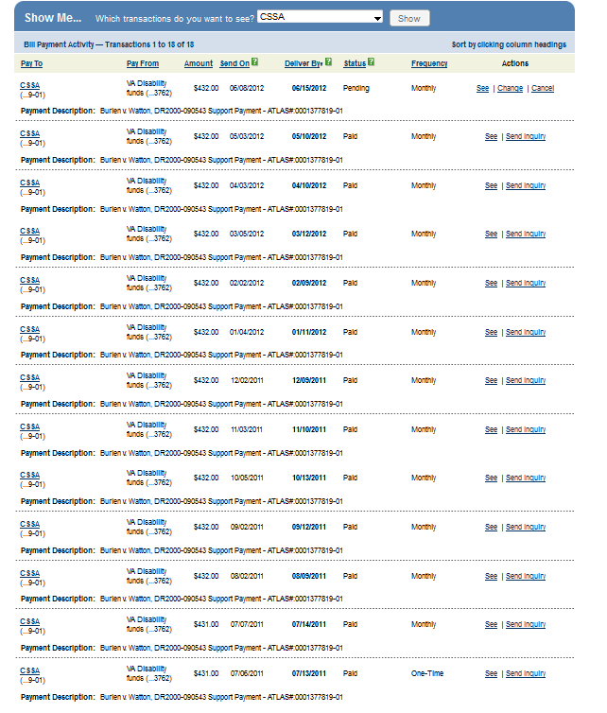
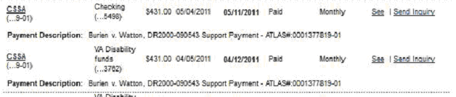
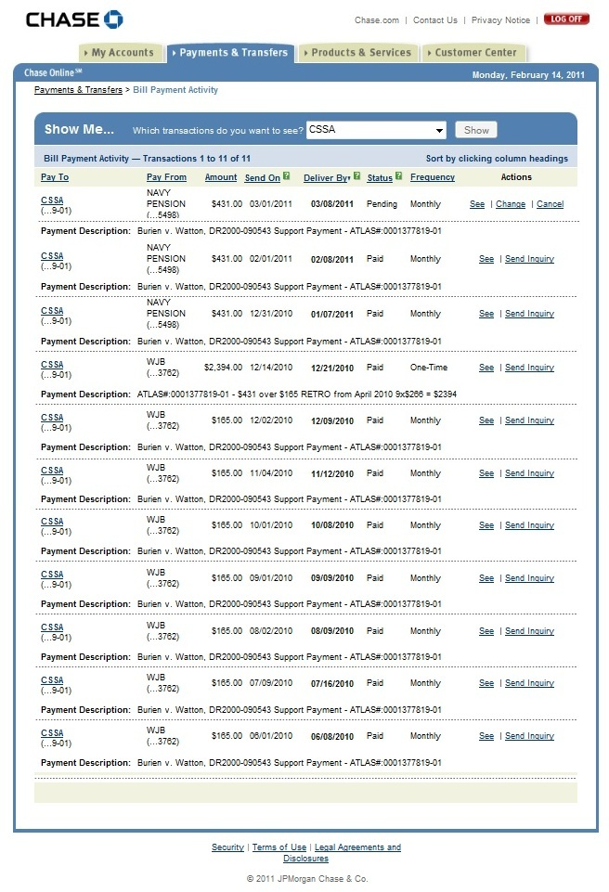

06/08/10 through 05/10/2012
$12,759 paid in Child Support to mother

(Total includes DES CS levy $1883 of 02/02/11)

Petitioner’s EXHIBIT (E)



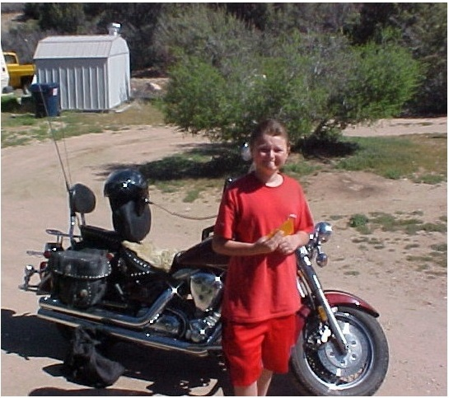

IN THE SUPERIOR COURT
COUNTY OF MARICOPA, STATE OF ARIZONA

Walter J. Burien, Jr.,
DR2000-090543
Petitioner,
v.
ORDER
Debbie C. Burien (Watton)

Respondent.

This matter having come before the Court through Petitioner’s EXPEDITE REQUEST FOR ORDER OF THE COURT SUMMER VISITATION, and with good cause apparent; IT IS HEREBY ORDERED that;

- Walter J. Burien, Jr. the father of the child John Joseph Burien shall have summer visitation with the child commencing 10 AM from Saturday, June 2nd 2012 until Sunday, August 26th 2012. The mother, Debbie Watton shall bring the child to the father in Saint Johns, AZ on 06/02/12 at 10 AM with this and all other exchanges-taking place at the Saint Johns, Police Station located at 1190 W. Cleveland St. The father shall return the child to the mother at the end of summer visitation, August 26th 2012 at 5 PM, and exchange the child at the Prescott Police Station, Prescott, AZ.

- The mother if she wishes to exercise alternating weekend summer visitation with the child, upon 24-hours notice by phone given to the father, may pick up the child at the Saint Johns Police Station at 5-PM on Friday the 15th and 29th of June and return the child for exchange back to the father by 5 PM Sunday the 17th of June 2012. If the mother is exercising weekend visitation on June 29th 2012, she shall return the child July 1st 2012 at 5 PM.

- In July 2012 the mother if she wishes may exercise weekend visitation, upon 24-hours notice by phone given to the father on the 2nd and 4th Friday of the month, and in the month of August 2012 the 2nd Friday of the month.

- Both parents will cooperate with each other in the best interests of the child and shall not speak negatively of the other parent.

- The parents will comply with the terms of this court order and may be held in contempt if they fail to do so. The father or the mother may not take the child outside of the state of Arizona during summer visitation with the father, or weekend visitation with the mother.

DONE IN OPEN COURT this day of May 2012.

_______________________________
Honorable Judge David B. Gass

