Walter J. Burien, Jr.
P. O. Box 2112
Saint Johns, AZ 85936
Phone (928) 458-5854
January 31st 2013

Yavapai Superior Court
Clerk of the Court
120 S. Cortez St.
Prescott, AZ 86303

Filing Counter - Clerk of the Court:

CASE: P1300CR201201330

ENCLOSURES:
- One Original dated 01/31/13 – and one copy for conforming of: MOTION FOR FINDING OF: NON-COMPLIANCE – AND ORDER, with exhibits “A” through “D” and;

- One Original dated 01/31/13 and one copy for conforming of: MOTION FOR REINSTATEMENT CASE NO. P1300CR201201330, mailed this 31st day of January 2013 USPS 1st Class Mail, delivery confirmation # 9400 1096 9993 9540 9386 89

Please conform the copies of the two documents and return in the self-address stamped envelope.
I thank you in advance for your cooperation in this matter.
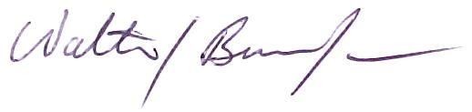

Walter J. Burien, Jr.

