Walter J. Burien, Jr.
P. O. Box 2112
Saint Johns, AZ 85936
Phone (928) 458-5854
March 8th 2013

Yavapai Superior Court
Clerk of the Court
120 S. Cortez St.
Prescott, AZ 86303

Filing Counter - Clerk of the Court:

CASE: P1300CR201201330

SENT US 1st CLASS MAIL
DELIVERY CONFIRMATION # 9400 1096 9993 8440 6231 52
ENCLOSURES:
- One Original dated 03/02/13 – and one copy for conforming of: MOTION FOR RECONSIDERATION OF ORDER DENYING DATED 02/11/13, with attached exhibit “A”

Please conform the copy of the document and return in the self-address stamped envelope.
I thank you in advance for your cooperation in this matter.
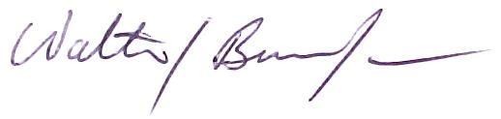

Walter J. Burien, Jr.

